**User Stories Example**

**Movie Ticket Booking**

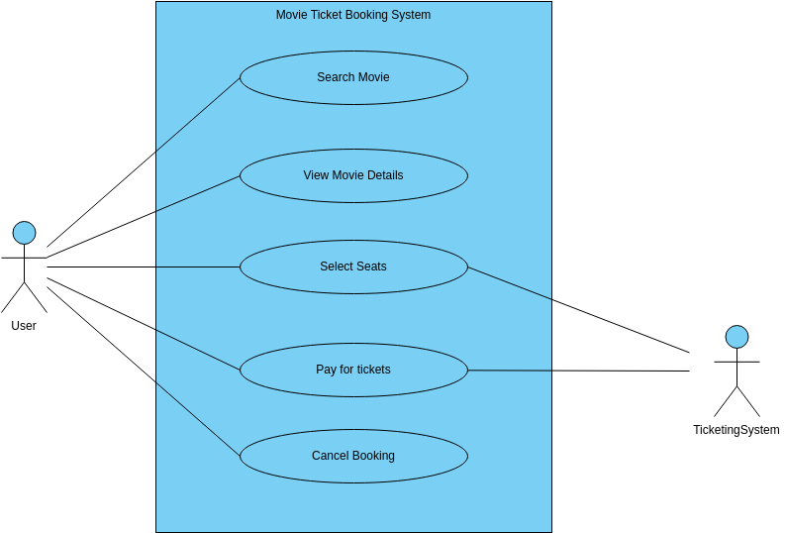

**Epic 1: User Account Management**

**User Story 1.1: As a user, I want to sign up for a new account so that I can book movie tickets online.**

* Acceptance Criteria:
  1. Users can register with an email and password.
  2. Upon registration, users receive a confirmation email.
  3. Users can edit their profile information after registration.

**User Story 1.2: As a user, I want to log into my account so that I can access my booking history and preferences.**

* Acceptance Criteria:
  1. Users can log in with their email and password.
  2. After logging in, users can see their past bookings and update their preferences.

**Epic 2: Movie Search and Booking**

**User Story 2.1: As a user, I want to search for movies released nearby so that I can plan for a movie outing.**

* Acceptance Criteria:
  1. Users can search for movies by title, genre, or location.
  2. Search results show movie details and nearby theaters.
  3. Users can filter search results by date, time, and theater.

**User Story 2.2: As a user, I want to book tickets for a specific movie and showtime so that I can reserve seats in advance.**

* Acceptance Criteria:
  1. Users can select a movie, showtime, and number of tickets.
  2. Users can view available seats and select their preferred seats.
  3. Users can confirm their booking and receive a confirmation email.

**Epic 3: Payment and Checkout**

**User Story 3.1: As a user, I want to add tickets to my cart and proceed to checkout.**

* Acceptance Criteria:
  1. Users can add tickets to their cart.
  2. Users can proceed to checkout smoothly.

**User Story 3.2: As a user, I want to make a secure payment for my tickets.**

* Acceptance Criteria:
  1. Users can choose from various payment options.
  2. Payment details are entered securely and processed without errors.